Proposal
Version 1 | 10/10/2025

Grainger plc
Service Cloud Implementation - RRB

Contents
1. Executive Summary 3
1.1 Introduction 3
1.2 The Business Opportunity 3
1.3 The Project 3
1.4 The Business Benefit 3
1.5 Why Open Box 4
2. Open Box Overview 5
2.1 About Open Box 5
2.2 Purpose, Vision and Primary Goal 5
2.3 Our Clients 5
2.4 Our People 6
2.5 Qualifications & Certifications 6
2.6 Examples of Similar Work 7
3. Proposed Solution 9
3.1 Scope of Work 9
3.2 Future Functionality 10
3.3 Technical Overview 10
3.4 Data Migration 14
3.5 Support 14
3.6 Training 15
3.7 Assumptions 15
3.8 Exclusions and Limitations 15
4. Project Methodology & Governance 16
4.1 Discovery Phase Consulting 16
4.2 Sprint Zero - Design 16
4.3 Delivery 16
4.4 UAT 17
4.5 Project Management 18
4.6 Project Governance 18
4.7 Project Team 19
5. Project Costs & Timeline 20
5.1 Recommended Project Phasing 20
5.2 Project Costs & Timeline 20
5.3 Dependencies 21
6. Next Steps 23
7. Acceptance 24
8. Appendix A – Grainger Mock-Ups 25
- Executive Summary
- Introduction
This proposal has been prepared at the request of Grainger plc and outlines the implementation of case management functionality in Grainger’s Salesforce org that will guide users through new business processes arising from legislation to be introduced in the anticipated Renters’ Rights Bill.
This proposal outlines Open Box’s approach to the project, including the scope of delivery, approach, project governance, the project team, indicative timelines, and pricing.
- The Business Opportunity
The Renters’ Rights Bill overhauls the formal rent challenge process, eliminating the risk to tenants of contesting rent increases. A systemised process to manage these challenges is necessary to ensure that all relevant information is captured in order to suitably motivate for the rent increase, identify undue tribunal delays that may be challenged, and keep a record of lessons learned and tribunal reasoning that may inform future rent-setting strategy and bolster future cases.
The Renters’ Rights Bill affords tenants greater rights to request a pet. This change in legislation provides an opportunity for Grainger to pilot the introduction of pet rent, require tenants with pets to agree to a pet policy, and maintain a register of pets across all properties. Managing these new processes within Salesforce would enable pet applications for new tenants to be coupled with the existing lead-to-lease process, automated reminders to be sent to request updated pet documentation, and existing integration to be leveraged to generate pet licences in Qube.
The Renters’ Rights Bill increases evidential standards and tightens procedural requirements, making it more challenging across the board to end a tenancy (including for antisocial behaviour). This heightens the importance of a streamlined, defensible process with clear documentation, consistent evidence gathering and properly issued notices so that landlords can still lawfully and effectively serve notice on tenants whose behaviour poses a genuine risk to others or the property. Grainger’s current process to serve notice is very manual with offline checklists and a ‘denied list’ managed in Excel. Implementing a systemised process to collate evidence and serve notice would ensure that an appropriate level of evidence is collected, stakeholders are kept informed, and tasks and follow-up activities are completed in good time.
- The Project
Open Box Software will customise case management functionality within Grainger’s Salesforce Org to manage new pet applications, ASB possession orders and formal rent challenges. A centralized, digital pet register will be created in Salesforce, and pet rent licences will be generated and integrated to Qube.
- The Business Benefit
The project has the potential to enhance the business value that Salesforce provides to Grainger and its customers with:
- A robust process to ensure all the necessary information is captured in a timely manner to support legal procedures, improve the likelihood of successful outcomes, and inform future decision-making.
- Intuitive, online processes for a user-friendly customer experience to help improve tenant retention.
- Management visibility into critical processes, SLAs and KPIs.
- Enriching the single view of customer within Salesforce.
- Moving toward a single, centralised and accessible record of all customer communications.
- Improved return on investment in existing Salesforce licences.
- Improved efficiency through automations and visibility between related processes (such as new lease applications and pet applications, or tenancy reviews and formal rent challenges), thereby reducing the manual effort required to find and update related data.

- Why Open Box
The following benefits underscore the value and expertise that Open Box offers, ensuring successful project delivery and long-term client satisfaction.
- Global Real Estate & BTR Experience: Open Box has collaborated with leaders in the real estate industry for 24 years, including working with build to rent (BTR) clients across the UK and US. As CRE specialists we bring a unique collective intelligence within this industry, leveraging a wide range of technologies to deliver solutions tailored to address the specific challenges and opportunities within the industry.
- Salesforce Experience: Open Box, a certified Salesforce Consulting Partner, is able to design and implement new solutions, or customise existing solutions, to suit your unique needs. By ensuring you are using the right features and licenses, and that your applications are robust, scalable and well adopted within your organisation, we help you maximise the return from your investment in Salesforce and unlock the full value of the Salesforce platform.
- Grainger Experience: Open Box has worked with Grainger as a Salesforce implementation and consulting partner since 2023. During this time Open Box has developed extensive knowledge of Grainger’s Salesforce org and business operations, enabling the team to hit the ground running with any new projects.
- Proven Track Record of Delivery: Open Box has delivered hundreds of projects to high-profile Real Estate clients. Over the past two years, Open Box has successfully delivered numerous Salesforce projects for Grainger including End of Tenancy, Commercial Lead to Lease, Right to Rent, Rent Smart Wales, marketing website integration, Tenancy Review project, as well as implementing a Single View of Tenancy within Salesforce. Importantly, the Tenancy Review project has already introduced Case Management to deal with tenant queries generated during the tenancy review process.
- Collaborative & Flexible Approach to Delivery: Open Box uses an agile delivery approach that encourages collaboration with stakeholders and provides flexibility to accommodate adjustments during the project. Grainger will be involved in the process, providing feedback throughout the project and will receive regular demonstrations of progress. Governance and reporting structures will be in place to ensure delivery is aligning to business needs. This collaborative approach will ensure knowledge transfer and a smooth transition to the Grainger team.
- Long-Term Relationship Focus: Open Box is committed to fostering long-term relationships with our clients by building a reliable partnership, as evidenced by our extensive history of successful project deliveries. Our commitment is demonstrated by the fact that our very first client remains with us after 24 years.
- Trusted Advisor: Open Box prides itself on being able to provide advice and thoughts on most real estate technology solutions and products, acting as a trusted advisor on items that fall both inside and outside of the current project scope. When entering a relationship with Open Box you will have someone to reach out to for any advice including demonstrations around new and future technologies.
- Open Box Overview
- About Open Box
Since 2001 Open Box has partnered with leading global real estate owners, operators, and investors to deliver technology solutions that solve real business challenges. With over two decades of industry expertise, we have developed and delivered thousands of bespoke systems and consulting projects, and we continue to support more than 100 clients worldwide.
Our services cover custom software solutions, low-code Power Platform development, data and analytics, artificial intelligence, enterprise consulting in both Yardi and MRI, CMS-based websites, SharePoint solutions, and Salesforce – always tailored to the Real Estate industry.
As a Certified Salesforce Consulting Partner with extensive real estate knowledge, we bring a combination of platform expertise and industry insight. Our team stays ahead of Salesforce developments to ensure that our clients benefit from cutting-edge capabilities while receiving practical solutions. We pride ourselves on delivering projects on time, within budget, and to the highest standards.
More than a technology provider, Open Box is a trusted long-term partner dedicated to the journey – supporting our clients to harness technology to adapt, grow, and prepare for the future as they and the industry changes.
- Purpose, Vision and Primary Goal
Our company motto is simple: There’s Always a Better Way. This idea drives everything we do. Our commitment to finding a better way leads us to high-quality, long-term relationships both internally and with our clients. These relationships are our most cherished value.
Our vision is to be the technology partner of choice for top tier real estate companies, as we continually work towards a better way.
Our goal is to be a stable, respected, robust and always relevant company that specialises in delivering high-quality technology solutions to the real estate industry.
- Our Clients
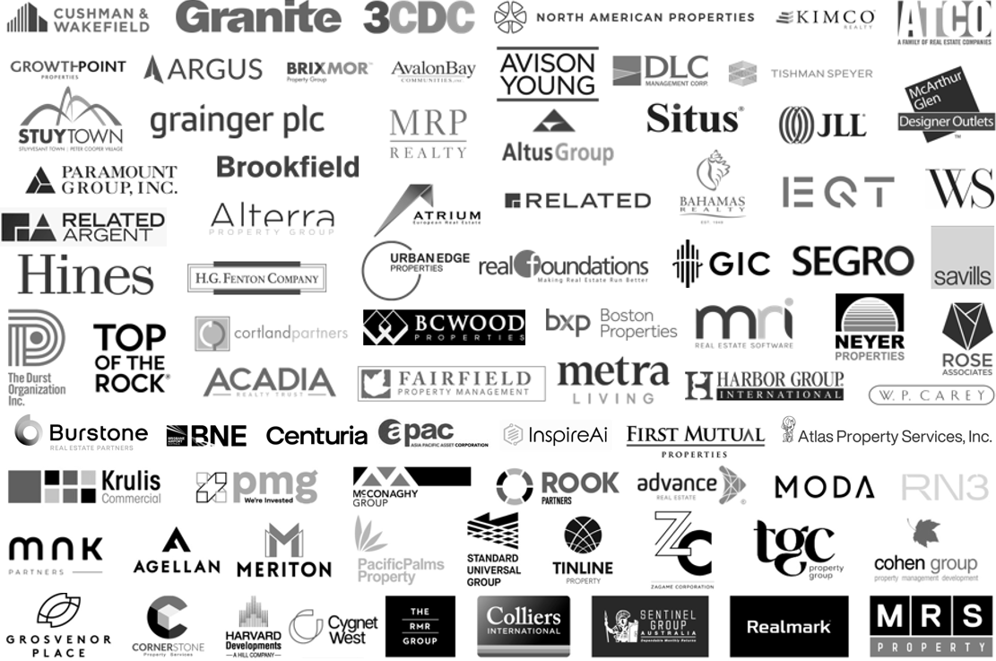
Figure 1: Examples of Our Clients
Open Box’s clients span the globe, having provided solutions across the United Kingdom, Europe, North America, South America, China, India, Australia and Africa.
We are trusted by well-known names in the industry.
- Our People
Our team comprises of over 200 staff members specialising in the major technologies relevant to the real estate industry.
Our core delivery team operates primarily out of South Africa, complemented by permanent on-site team members in the United Kingdom and North America.
- Qualifications & Certifications
All staff members are highly qualified with the vast majority holding postgraduate university qualifications in Information Systems, Computer Science, or Engineering fields.
- Microsoft
  - Microsoft Gold Certified Application Development House
  - Microsoft Certified Professionals across the Microsoft suite of disciplines
- Web/Mobile
  - Apple iOS, Android, Phone Gap / Apache Cordova / Xamarin, mobile website development.
  - HTML 5, CSS3, TypeScript and JavaScript.
  - Angular 2
- Salesforce
  - Certified Consulting Partner with 5 star customer rating
  - 61 Certifications
  - Led by Technical Architect with 18 years’ Salesforce experience
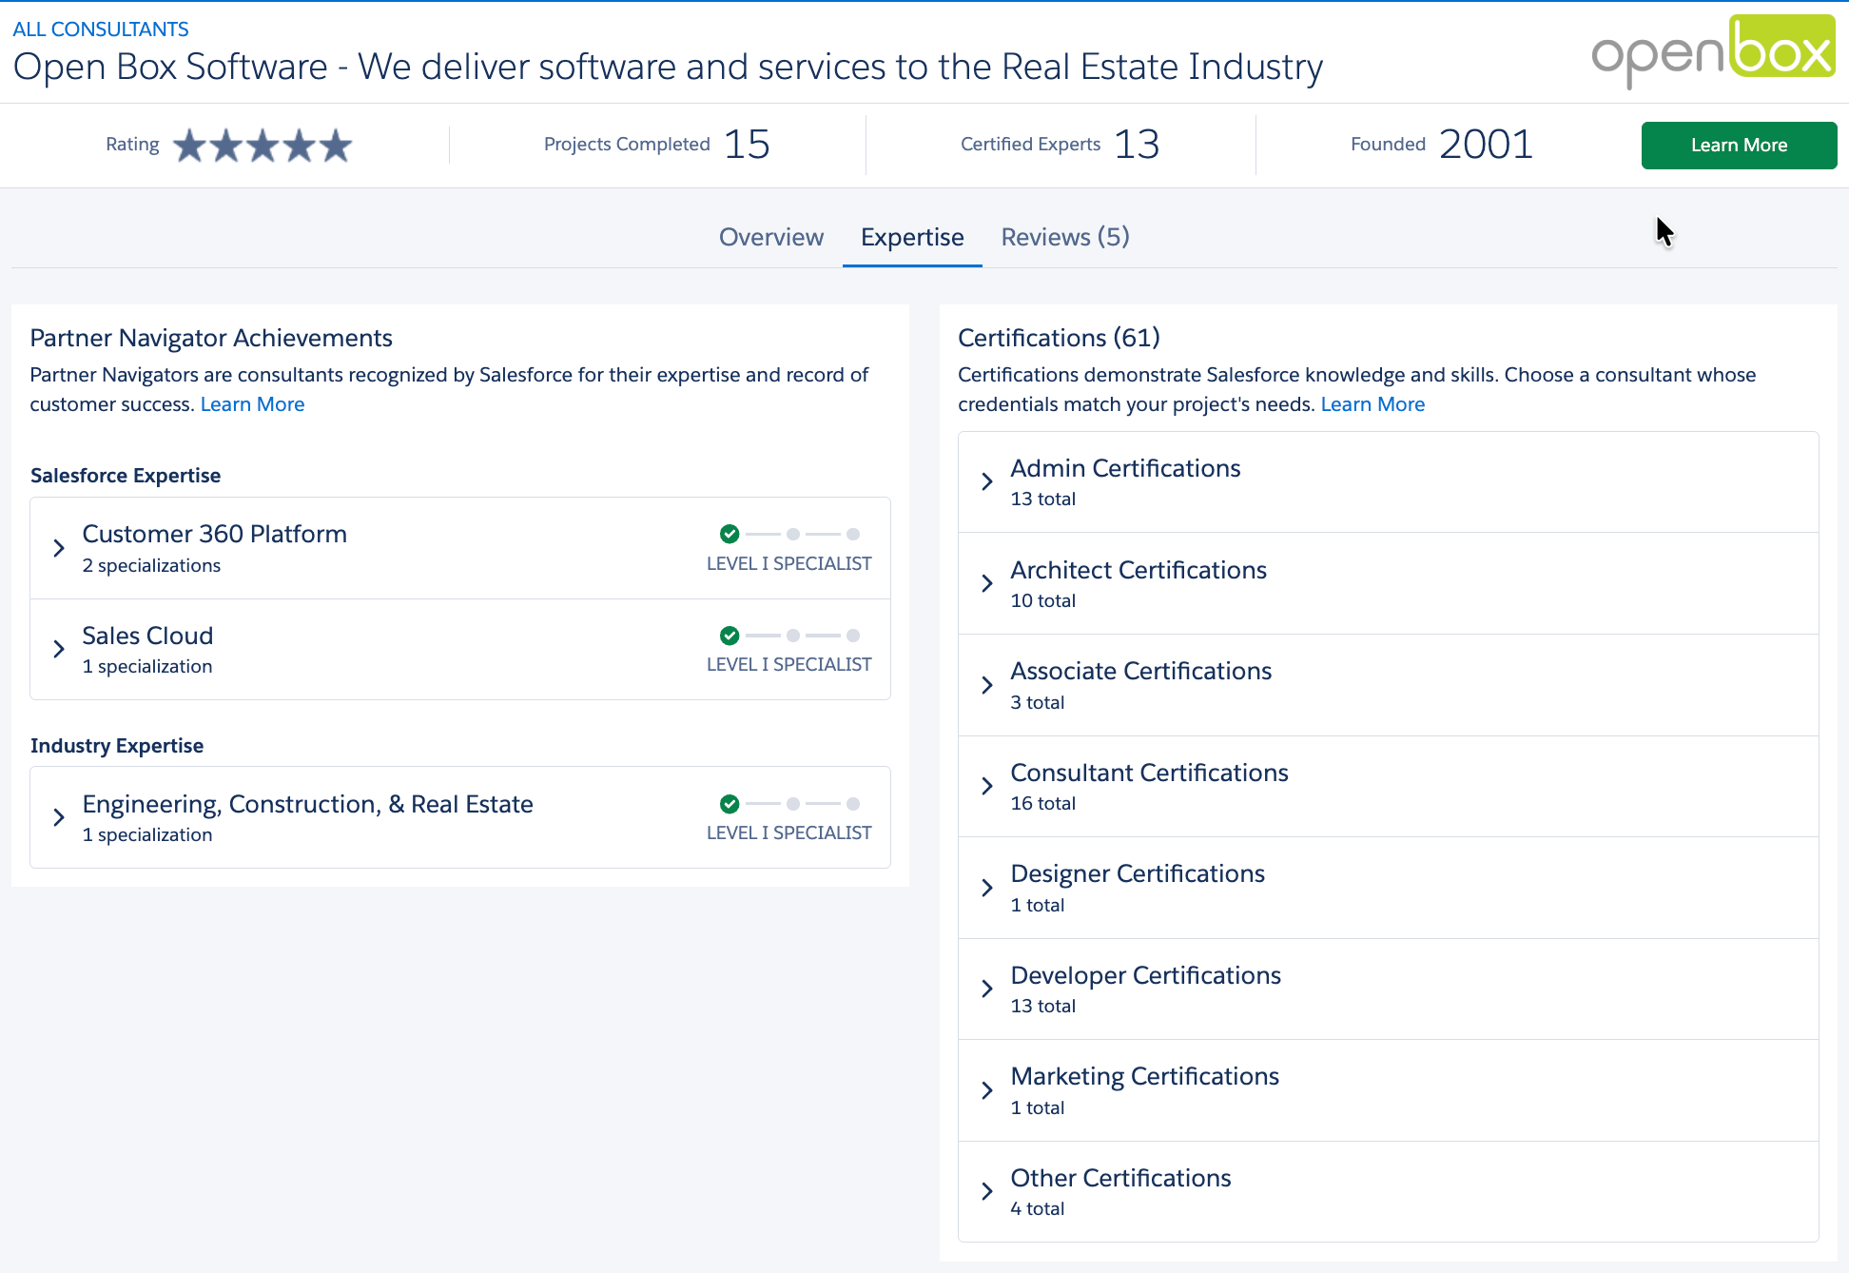
Figure 2: Open Box Consultant Listing on Salesforce AppExchange
- Examples of Similar Work
Open Box developed a Salesforce Case Management solution for a UK residential landlord, with a similar use case – wanting a single place where all related information for a complaint could be compiled and actioned.
The successful project delivered using the standard Case functionality available in Salesforce and provided the following key functionality:
- Single location to capture complaint details, including communication via email between the user and the customer. This includes the full email chain as well as the ability to log calls and provide general updates to other internal users.
- Milestones to track KPIs and ensure timely completion of process, including escalations
- Audit tracking of key fields, stage changes, completed or overdue milestones.
- Ability to link to multiple other complaints.
- Ability to automatically link to tenants and/or units based on complainant details.
- Distinct permissions to allow select users to complete certain activities, as well as restricting the visibility of sensitive cases to the correct people.
- Compliance with The Property Ombudsman complaints process in terms of email templates, SLA’s etc.

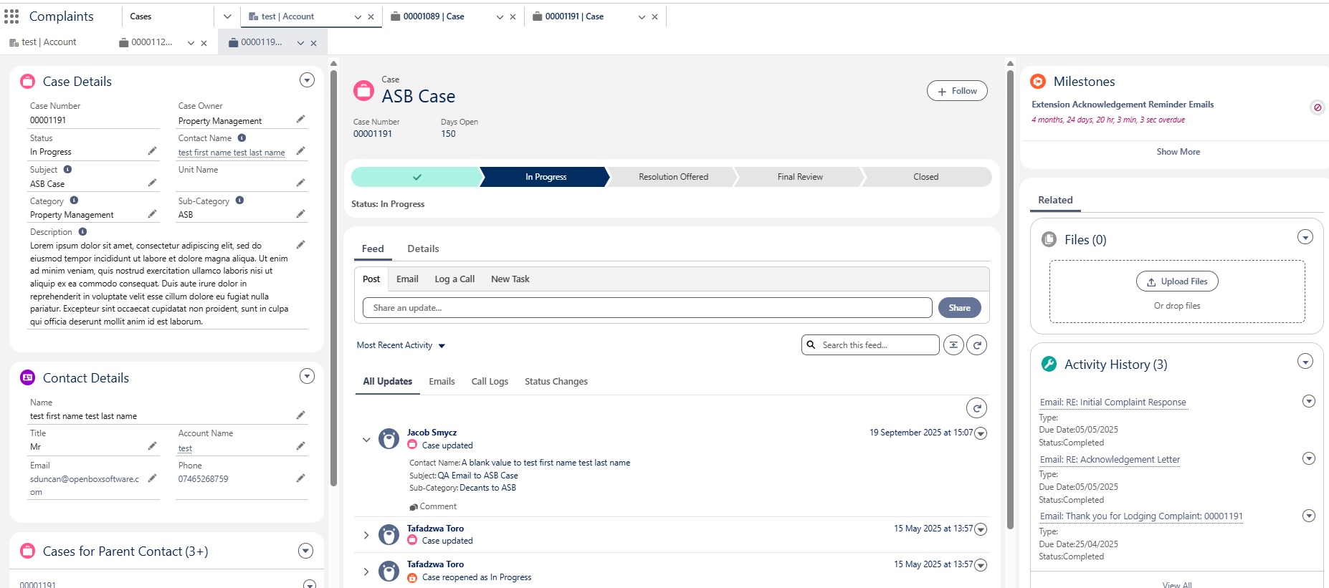
Figure 3: Case Management Functionality Delivered

    - Grainger Case Management Pilot
As part of the recent Tenancy Review project delivered for Grainger, Open Box implemented a case management pilot in the Grainger org.
In this instance case management is currently used for a very specific use case, namely when a customer sends an email to the dedicated Grainger tenancy reviews email address and that email cannot be linked to a tenancy review that is in progress.
Open Box automated the creation of a case when such an email is received, linking the case to an existing Salesforce contact, and identifying any tenancies and opportunities associated to that contact.
Given that the pilot was for a specific use-case which is expected to have low volumes, case management was implemented with minimal customisation. However this functionality already provides many of the requirements identified for the proposed project, including sending and receiving communications through the case, the ability to create linked tasks and attach files and notes.
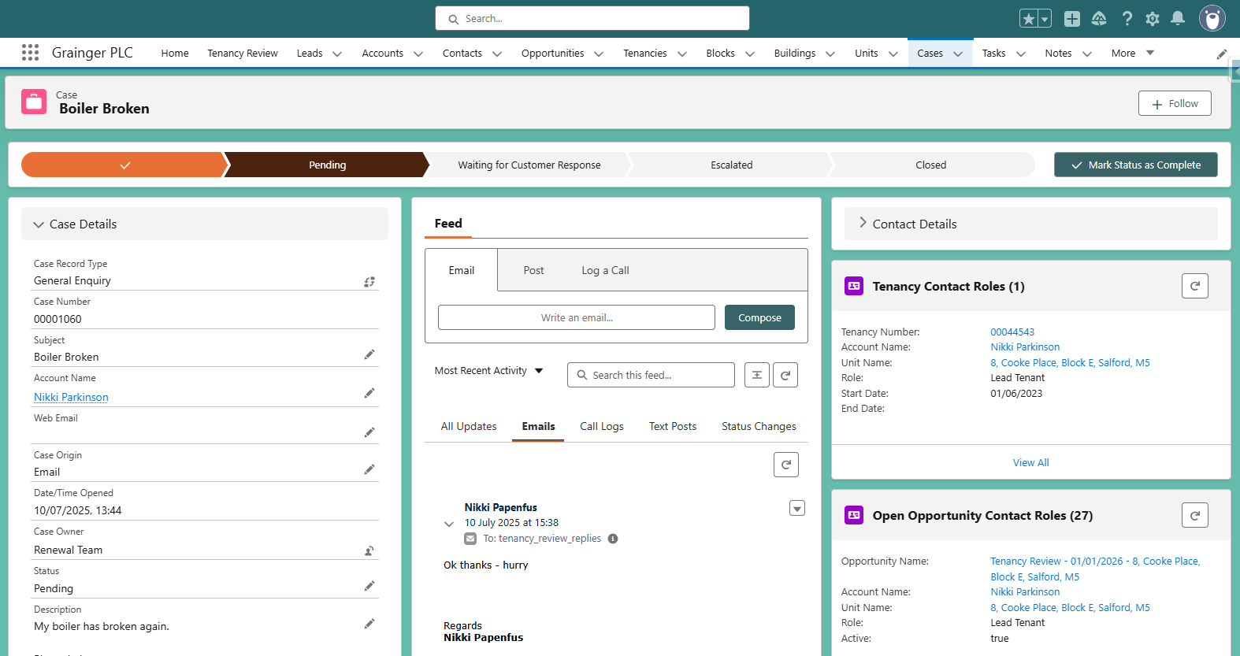
Figure 4: Existing Grainger Case
- Proposed Solution
Open Box proposes to implement customisations in the Grainger Salesforce Org to manage ASB possession orders, formal rent challenges, pet registers and pet rent licences.
- Scope of Work
The solution will address the following objectives:
- Manage ASB Possession through customised Salesforce cases that guide users to capture the required information at each stage of the process.
  - An online form (accessible for tenants from the MyGrainger app) enables reporters to submit reports and evidence online.
  - Users would be alerted to potential duplicate cases and could link multiple reporters and multiple perpetrators to a single case.
  - Automated notifications would be sent to reporters and internal stakeholders. Warning letters and Section 8 Notices would be generated & sent to tenants.
  - A full history of evidence and communications would be saved against the case which is visible and accessible from the linked tenancy, unit, perpetrator(s) and reporter(s).
- Manage Formal Rent Challenges through cases that prompt users to capture the requisite information to respond to the challenge and to track delays; notify internal stakeholders at key stages in the process.
- Manage Pet Applications for new and existing tenants through cases.
  - Tenants would complete an online pet application form, sent via email or accessed from the MyGrainger app.
  - Pet applications may be accepted or rejected automatically, or routed to the relevant team for approval/rejection as applicable; notifying tenants of the outcome and next steps.
- Manage Pet Policies & Capacity Limits – Users have visibility into which buildings and units are pet-friendly and can see at a glance where a building is at, or reaching, capacity.
- Centralised Pet Register – Enable users to search and identify pets across the portfolio as well as to drill down into full pet details, documents, approvals and a full audit history.
- Generate Pet Licences – The solution would generate and send pet licence contracts for tenants to sign on successful completion of a pet application, where applicable. Existing pet licences may need to be updated with increased pet rent where tenants are adding further pets.
  - GREP integration would push the pet licences to Qube.
- Reminders to Submit Updated Pet Documentation – Automated reminder notifications would be sent to tenants with a link to submit updated vaccination records & insurance documents through an online form.
- Remove Pets Mid-Tenancy - Tenants would be able to complete an online form to notify Grainger that a pet has been rehomed or passed away which could be accessed from the MyGrainger app. A case would be created to ensure that the pet rent is ended, or that the pet licence is updated with reduced pet rent, as necessary.
- Update the Pet Register at End of Tenancy – Enhancements to the End of Tenancy (EOT) process would automatically update the pet register on confirmation of move-out, and notify the Credit Control team to end the pet rent in Qube.
- Usability – The solution would deliver case design that provides consistency across all case types for ease of training & adoption, as well as the ability for users to pick up a case they have not worked on before and easily know what needs to be done next.
- KPI Tracking – Users would be able to see at a glance whether a case or task is approaching or passed a deadline; SLA escalations may be automated.
- Operational Dashboards provide easy access to information, items to be worked on, and KPIs.
- Future Functionality
Additional functionality that is not included in the scope of this project as outlined above, but which may be addressed in future releases, includes:
- Managing Complaints, Incidents & Grumbles using Salesforce case management, including compensation approval workflows.
  - Create visibility by linking related activity (such as a complaint about a tenancy review negotiation to the tenancy review opportunity that contains the full history of communications and negotiations).
  - Create a linked ASB Possession case from an incident or complaint.
- Alternate Possession Case Workflows – Customising possession case workflows arising from rent arrears or other scenarios.
- Managing Repairs & Maintenance Issues (for non-Axis buildings) using Salesforce case management, including automated case creation & tracking from the MyGrainger app.
  - Creating work orders from a complaint or incident, where required.
  - Notifying contractors of uncaged pets before onsite visits.
- Centralized Management of All Ad Hoc Communication from Customers using Salesforce case management that automates case creation from website queries, emails to feedback@graingerplc.co.uk, and general enquiries from the MyGrainger app.
  - Assigning cases to the relevant team for follow-up, or responding from standard templates.
  - Ability to easily convert to a complaint or maintenance issue, where required.
- Enhanced Mobile Functionality – Includes enabling residents to create and monitor pet applications, manage pet details, receive reminders and upload documents in the MyGrainger app.
- Automatically Sourcing Comparable Rent for formal rent challenges.
- Leveraging AI to provide Actionable Insights such as assessing formal rent challenge lessons learned and tribunal reasoning to suggest how to best achieve future rent increases; automating the identification of undeclared pets; predictive analytics to assess the likelihood of pet ownership.
- Technical Overview
This document provides a high-level design for the proposed functionality to be implemented on Grainger’s Salesforce org.
This design does not cover the lower level detail (such as fields, profiles, automations and validation rules); these will be designed and documented at user story level during the agile delivery phase.
The case management functionality delivered by this project will lay the foundation for future use cases - e.g. repairs and maintenance requests (with digital intake and contractor notifications), formal complaints (with entitlements/milestones and audit trails), knowledge-backed Q&A (self-service and agent assist), and rent arrears workflows (templates, payment-plan tracking, and integration hooks to finance/PM systems). This phased approach reuses common components (record types, flows, Omni‑Channel, reporting, etc.) so that new services can be added without re‑platforming, providing a broader Single View of the Customer and a consistent operating model across property, customer and finance teams.
    - Technology Stack
The proposed solution would leverage Grainger’s existing technology stack. Cases would be managed in Salesforce, pet licenses would be integrated to Qube via GREP and advanced reporting would be provided via Power BI driven by data (from Salesforce and other applications) in the Grainger data warehouse.
    - Salesforce Licensing
It is understood that all users of the proposed solution have already been provisioned with full Salesforce licences. It should therefore not be necessary to purchase additional licences.
It is not expected that the solution will require any additional costs for data and file storage within the next 3 years of operation. This is based on current understanding and scoped features and is subject to change if additional requirements (e.g. file storage) are introduced.
    - Third-Party Applications
      - FormAssembly
Grainger is currently utilising an Enterprise FormAssembly subscription that includes a Salesforce connector. FormAssembly would be utilized to enable customers and third parties to create or update case information online.
It is expected that Grainger, or an integration partner, would be responsible for styling the FormAssembly pages and embedding these in the Grainger website, if required.
      - MyGrainger App
It is expected that minor enhancements to the MyGrainger app would give tenants access to links to open FormAssembly forms that would integrate directly with Salesforce. Grainger, or an integration partner, would be responsible for developing and testing any such changes.
The initial release would not introduce any new, direct integration between Salesforce and the MyGrainger app.
    - Salesforce Strategy
      - Document/File Management
The proposed solution will introduce additional file storage requirements depending on the natures of files that are expected to be submitted with the case records (photographs, videos, etc.). Standard Salesforce Files functionality will allow for users to upload files and relate them to one or more Case records, including common document types (pdf, doc, docx, word, etc.), video and audio files (mp4, avi, mp3, etc.) and images (jpg, png, bmp, gif, etc.). Files up to 2GB can be uploaded and stored in this way.
Note that the standard Salesforce Files functionality proposed for file management does not allow for users to specify a “File Type” (e.g. “evidence”). A custom upload screen can be built if required to categorise files at the point they are uploaded.
      - Archival Strategy
Salesforce data storage capacity is limited and is determined by a base allocation at org-level plus a per-user allocation. Any overage will require the purchase of additional storage from Salesforce. Additionally, a high number of records of any one object can result in large data volume (LDV) performance limitations (report timeouts, slow page loads, etc.). Thus it is desirable to operate within the allocated capacity if possible and implement an archival strategy to move data off-platform at a point in time where users no longer need to interact with them.
In order to calculate data and file volumes, the following assumptions have been used:
- Number of units: 13 000 in year 1, scaling to ±30 000 in year 5
- Number of cases per year: 1 case per unit
- Number of pet requests per year: 1 pet request for every 3 units
- Number of files per year: 1 file per case @ 2MB / file average size
Table 1: Estimated Data Volumes
Data Point | Y1 | Y2 | Y3 | Y4 | Y5 | Cumulative Volume | Data / File Storage (GB)
# Cases / year | 13 000 | 17 333 | 21 667 | 26 000 | 30 333 | 108 333 | 0.21
# Pet Requests / year | 4 333 | 5 778 | 7 222 | 8 667 | 10 111 | 36 111 | 0.07
# Files / year | 13 000 | 17 333 | 21 667 | 26 000 | 30 333 | 108 333 | 211.59

Based on current file storage usage within the Grainger Salesforce org (300GB used of 610GB limit) the existing document/file management strategy is considered to be adequate for the next 3+ years, but may require an archival solution depending on actual volumes encountered once deployed to production.
It is assumed that the current data storage usage within the Grainger Salesforce org (18.8GB used of 15.6GB available) will be brought into compliance with at least 2GB available. This would remove the need for any immediate implementation of an archival strategy for cases and pet requests. Given that the above calculations are based on assumptions, it is recommended that volumes be monitored during the course of operations. Based on actual record volumes a suitable archive strategy and timelines can be planned.
      - Mobile Strategy
The functionality envisaged for this project will be for desktop browsers only. There is no requirement for the Salesforce functionality to be available on mobile devices through the Salesforce mobile app.
      - Reporting Strategy
Operational reporting needs can be met via Salesforce reports and dashboards. Should deeper analytical capabilities be required, these can be met via a BI solution such as CRM Analytics or Power BI coupled with an Azure SQL data warehouse.
    - Data Model
      - Data Sharing & Security
The Grainger Salesforce org currently has a public read/write org wide default (OWD) for all key objects (Account, Opportunity, Tenancy, Case) and allows all users to view all records. Where no security requirements exist to restrict visibility, this solution provides full visibility to all users and facilitates easy collaboration (e.g. users are able to update tasks belonging to a colleague when the colleague is absent). It should be noted that this public OWD still allows for editability to be restricted by user/role/profile - for example, tenancy fields that are mastered in Qube would not be editable by users in Salesforce.
The functionality proposed for this solution may require changes to the existing sharing model for the Case object to limit visibility of certain Case types. This can be implemented by changing the Case to have a private OWD, with sharing delivered by one or more of the many security mechanisms provided by Salesforce (role hierarchy, sharing rules, etc.). Based on requirements, sharing access can be used to limit users to viewing (not deleting) files/records. Validation rules can be implemented to further restrict editing/deleting based on record details (e.g. prevent deletion of files on a closed Case).
      - Entity Relationship Diagram
The following key changes are proposed to the high-level data model in order to support the proposed functionality:
- Cases – New record types will be added to the existing Case object for each case scenario such as: Pet Application for a New Tenant, Pet Application for an Existing Tenant, ASB Possession, and Formal Rent Challenge.
  - Each record type may have its own workflow (stages), SLAs, business rules and validations.
  - Documents and files may be attached to a case.
  - Each case would have an activity timeline with associated tasks, emails and call logs.

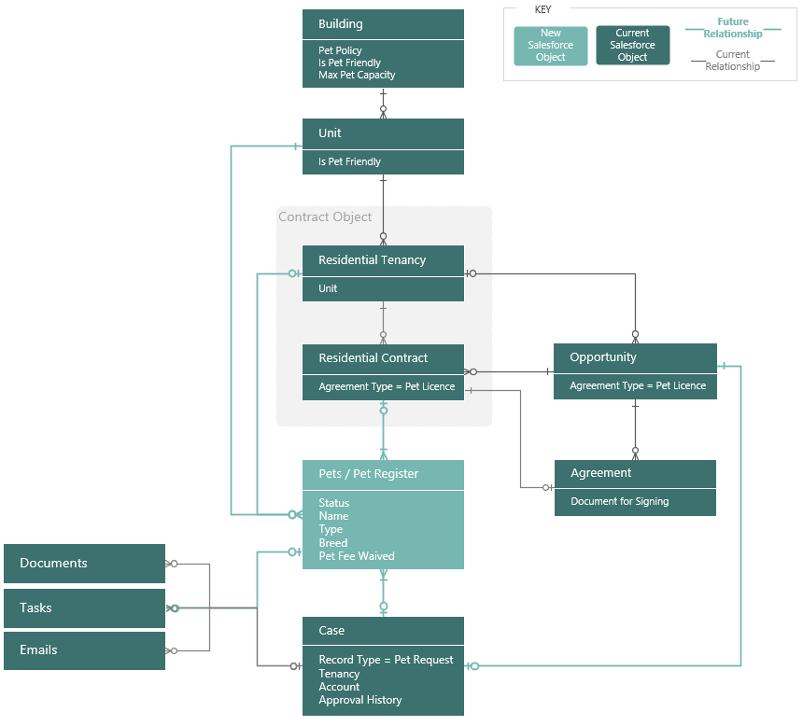
Figure 5: Proposed High-Level Data Model - Pets
- Pets - A new pet object will be created that forms the basis of the pet register.
  - A pet request case would generate one or more pet records; however pet records could also be added and maintained independently of a pet request case.
  - Pet records would be linked to, and visible from, the unit and tenancy.
  - Documents and files may be attached to a pet record (for example vaccination certificates or a photo).
  - Each pet record would have an activity timeline with associated tasks and emails (such as reminder emails to provide updated documentation).
  - Where a pet record was generated from a pet request case, the case would be accessible along with a full history of the request approval or rejection.
  - A full history of all current pets, prior pets and pets from rejected applications would be maintained and managed via the applicable status.
- Pet Licence – The existing Residential Contract record type in the Contract object will be used to save pet licences, in a similar manner to existing parking licences.
  - A new agreement type and document type would identify pet licences.
  - The pet licence will be linked to, and visible from, the related residential tenancy.
  - The pet licence would have a separate status, start date and end date to the residential tenancy allowing for pet licences to start or end mid-term.
  - Pet licence documents would be generated and sent to customers for signing via the existing Agreement object and Adobe Sign functionality.
- Building – Both buildings and units could be identified as allowing pets. Each building may have its own pet policy and pet capacity limits.
  - Note that given the current data structure in which a unit’s floor is a picklist value (as opposed to a separate object), it will not be possible to configure pet capacity by floor. There will however be limited ability to report on pet data at a floor level.
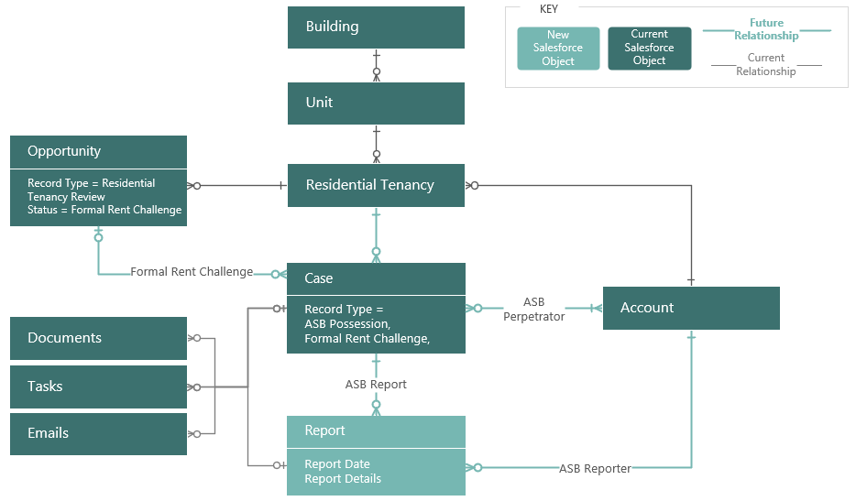
Figure 6: Proposed High-Level Data Model – Formal Rent Challenges & ASB Possession
- Formal Rent Challenge – Case records with a Formal Rent Challenge record type would be linked to, and visible from, the corresponding tenancy and tenancy review opportunity.
- ASB Possession Cases – Case records with an ASB Possession record type would be linked to the tenancy to be served notice as well as individual perpetrators (person accounts).
- Report - Each ASB case would have one more reports, each with a separate reporter. (Report records may be extended in future to include complaint, maintenance or incident reports as new case types are added over time.)
  - Documents and files (including evidence of antisocial behaviour) may be uploaded for each report. Separate emails or correspondence sent to an individual reporter will be linked to the report and visible in an activity timeline.
    - Integration
      - Qube
Existing GREP integration between Salesforce and Qube will be enhanced to push new pet licences in Qube.
It is expected that Grainger, or an integration partner, would be responsible for developing and testing all GREP enhancements. The scope and cost of this is not included in the Open Box project cost.
- Data Migration
No data migration is expected.
- Support
Open Box will provide post go-live support for 10 working days immediately following the production deployment.
After this period, any critical production issue will be addressed by the existing support agreement with Open Box. Any non-critical changes may be addressed though the existing BAU contract.
- Training
Open Box will deliver a training manual for end users, detailing the solution functionality. Grainger will be responsible for end user training and change management.
- Assumptions
The following assumptions have been made; incorrect assumptions may affect project cost and timelines.
- Five (5) new case record types will be created: Pet request for a new tenant, pet request for an existing tenant, removing a pet mid-term, ASB Possession, Formal Rent Challenge.
- Grainger will be responsible for styling any FormAssembly pages and embedding these in the Grainger website if required.
- No additional pet management functionality will be required specifically for decants & internal moves.
- No new tenant surveys are required. The existing survey for new tenants will be updated to incorporate the pet application process, which falls outside of the scope of this project.
- Three operational dashboards (and underlying reports) will be delivered; one for each of the pet management, formal challenge & ASB possession case modules. Any additional reporting and dashboards may be added by Grainger over time.
- Exclusions and Limitations
In order to right-size the proposed project, certain functionality will be excluded. The following is not included in the cost or scope of this project:
- Future functionality listed above (including near miss & injury incident cases).
- Data migration (including prior or current ASB possession cases).
- Integration not listed above, including integration with Power BI, building access systems, housing management platforms, local authority portals, or MRI Evolution.
- Reporting on trends, heatmaps and metrics are expected to be addressed using separate BI reporting tools.
- This project does not include all functionality required for the Renters’ Rights Bill, including the generation of the new Section 13 documents.
- This project does not include any functionality to automatically delete or anonymise records or files captured in Salesforce during the case management process.
- Informal rent challenges will continue to be managed via the tenancy review process; additional case functionality is not required.
- This project only includes functionality for pet licenses being added as part of a new let, or a new pet being added to an existing tenancy. A once-off project to populate the pet register with existing pets will be addressed through a separate project or the existing BAU FTE engagement.
- Management of pet rent arrears & notifications to tenants of upcoming pet rent payments will form part of the existing arrears management process and/or a future arrears management module to be added to Salesforce, which falls outside of the scope of this project.
- Given the current data structure in Grainger’s Salesforce org, it will not be possible to configure pet capacity by floor. There will be limited ability to report on pet data at a floor level. Any changes to this data structure will require additional effort.
- Open Box will not develop, test or implement any MyGrainger app enhancements.
- Costs exclude any third-party costs, licence fees, subscriptions or services.

- Project Methodology & Governance
The delivery approach will be based on the agile SCRUM framework. An agile delivery approach allows for the early delivery of outcomes and provides flexibility to adjust for any unforeseen opportunities or issues uncovered during the project.
- Discovery Phase Consulting
Open Box will work with the Grainger stakeholders to review the requirements artefacts already documented by Grainger, reach consensus on the functionality to be addressed in Salesforce, and identify functionality that is best addressed in other systems or can be deferred for future enhancements.
Open Box will use their Salesforce and business analysis expertise to shape a future-state design that aligns with Salesforce features, best practices and minimises technical debt.
Open Box will deliver:
- Future-state process diagrams.
- Mock-ups of the proposed case layouts.
- A proof-of-concept, if necessary, that demonstrates aspects of the proposed solution.
- A feature backlog in Jira that captures the outcomes to be delivered and proposed implementation approach.
  - The features will be sized and prioritized relative to each other.
  - This feature backlog will be used during an iterative delivery phase to identify, develop and deploy the most valuable features.
  - Any features identified for possible future releases will also be added to the backlog.
- A revised forecast of the number of sprints, cost & timeline required to deliver the feature backlog proposed.
On completion of this phase Grainger will decide whether to continue with the project, reassess the project scope, or halt the project.
- Sprint Zero - Design
During a Sprint Zero phase, Open Box will work with the core Grainger project team in backlog refinement sessions to break down the features identified in the discovery phase into detailed user stories with acceptance criteria and technical designs.
Sprint zero will not deliver all user stories to be addressed in the project, but will provide a sufficient backlog of user stories that enables to delivery team to commence development.
- Delivery
Iterative delivery is achieved through a series of 3-week sprints.
The backlog of features and user stories will be maintained to track outcomes to be delivered and indicate priority of these outcomes relative to each other. The backlog will be a living artifact that will evolve as Open Box and Grainger collaborate and will serve as the single source of truth with regards to scope.
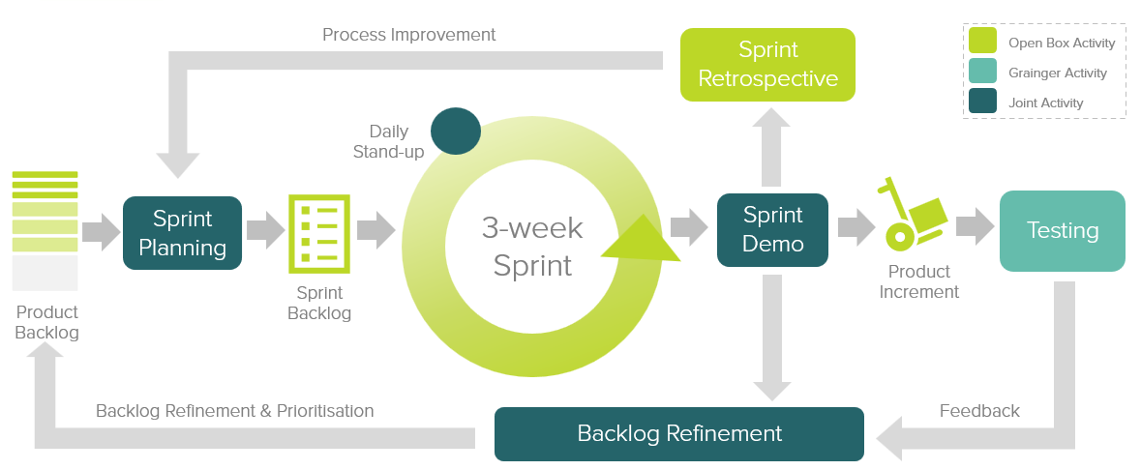
Figure 7: Agile Delivery Approach
Grainger representatives will be required to participate in the following during each sprint cycle:
- Backlog Refinement – Open Box and Grainger representatives will meet to prioritise user stories on the backlog as well as review and agree on acceptance criteria for user stories at the top of the backlog.
- Sprint Planning – Outcomes on the backlog will be selected for the next sprint.
- Demo – Open Box will meet with Grainger representatives to demonstrate the outcomes delivered in the past 3-week period.
- Testing – Open Box will be responsible for unit testing and QA testing of functionality. Grainger representatives will conduct user acceptance testing of new functionality delivered in each sprint and provide feedback within 1 week of the demo.
- Stand Up – Daily, 15-minute stand up calls will be held for the Open Box team to internally report on progress. Weekly, 30-minute stand up calls will be held with the Grainger team to provide feedback and give input on any questions that arise.
Feedback from demos and testing will be classified as either bugs or enhancements (depending on the user story and acceptance criteria). Bugs will be fixed in a subsequent sprint, whereas enhancements will be incorporated into the backlog and prioritized accordingly.
If it is expected that the critical functionality can no longer be delivered within the estimated cost and timeline, this will be communicated to Grainger who may choose to resolve this by adjusting the project scope and/or cost & timelines accordingly.
- UAT
Designated Grainger business users will be given access to a UAT sandbox to test the functionality end-to-end and ensure that the overall solution is functioning as expected.
Issues raised will be classified as bugs or enhancements (as above). Bugs will be fixed during the UAT period. Any other enhancements or new requirements will be added to the backlog for future development.

- Project Management
Open Box will deliver a progress report to Grainger on a regular basis, that will include:
- General status update
- Project risks
- Project milestones & timeline forecast based on the current scope.
Regular updates regarding any significant changes in scope or cost will be delivered to Grainger as and when they occur.
- Project Governance
The below meetings will be held for the governance of the project to ensure effective oversight, decision-making, communication and alignment with project objectives.
- Kick-off Meeting
  - This will occur once at the start of the project to formally launch the project and ensure all stakeholders have a clear understanding of the project goals, scope, governance structure, roles and responsibilities.
  - Grainger attendees: Project sponsor (lead), project manager, project team members, additional stakeholders.
  - Open Box attendees: Project manager and key project team members.
- Steering Committee Meetings
  - These will be scheduled periodically, in consultation with Grainger, to provide high-level oversight and strategic direction for the project and demonstrate progress to date. The steering committee will review project progress, major issues, scope changes, and ensure alignments with business goals.
  - Grainger attendees: Project manager (lead), project sponsor, steering committee.
  - Open Box attendees: Project manager, architect, business analyst.
- Programme Management Meetings
  - This will occur every 3 weeks to provide updates across all current projects, track progress against milestones, identify issues and review risks.
  - Grainger attendees: Project sponsor (lead), project manager.
  - Open Box attendees: Project manager, architect.
- Weekly Stand-Ups
  - This will occur weekly to provide progress on tasks, identify any obstacles and ensure everyone is aligned on immediate tasks and priorities.
  - Grainger attendees: Project manager, key project team members.
  - Open Box attendees: Project manager (lead), key project team members.
- Sprint Retrospectives
  - This will occur after each sprint to review the latest sprint to assess and identify improvements for enrichment of future sprints.
  - Open Box attendees: Project manager (lead), project team members.
- Post-Project Review
  - This will occur at the end of the project to review the project’s outcomes, lessons learnt and performance against the original objectives.
  - Grainger attendees: Project manager (lead), project sponsor, project team members.
  - Open Box attendees: Project manager, key project team members.

- Project Team
The project team is anticipated to be comprise of the following team members:
Table 2: Proposed Project Team
Role | Name | Experience
Salesforce Technical Architect | Sam Duncan | Salesforce architect and principal consultant with 18 years Salesforce experience. 18X certified.
Project Manager | Shaun Barrett | 20+ years project management experience with 11 of those years focussing on commercial real estate projects.
Senior Business Analyst | Nikki Papenfus | 16 years analysis experience on commercial real estate projects.
Residential Lettings & Operations SME (UK) | Jacob Smycz | 6 years working at Grainger plc / BTR experience. 7X certified
Senior Developer | Anjali Salecha | 18 years Salesforce development experience. 9X certified.
Developer | Mathew Cornfield | 3 years Salesforce development experience. BSc. Hons. Computer Science. 3X certified.
Quality Assurer | Khonani Davhana | 3 years Salesforce QA experience. BTech, Electrical, Electronics & Communications Engineering. ITQSB and 1X Salesforce certified.

Individual project team members may be substituted, at the discretion of Open Box, for others of similar skills and experience. The availability of specific individuals is subject to project timelines.
    - Availability
Open Box resources will be contactable and available for meetings via conference calls/video conferences:
- Monday to Friday 9am – 6pm South African time which corresponds to 7am – 4pm GMT, excluding public holidays.
All consultancy and all development work will be completed by Open Box offsite.
- It is not expected that the project requires Open Box resources onsite. Where onsite personnel are required, all reasonable expenses for travel and subsistence shall be reimbursed by Grainger. Open Box shall not bill any mark-up or administration fee onto any such expenses. Approval for expenses shall be obtained from Grainger prior to being incurred.

- Project Costs & Timeline
Open Box will provide the following services:
- Consultancy & Sprint Zero:
  - An Open Box Salesforce Technical Architect, Senior Business Analyst and Residential Lettings & Operations SME will be available on a time & materials (T&M) basis.
  - Time spent on these phases will not exceed upper bound estimates without prior approval from Grainger.
- Build Phase: An agile sprint team delivering in 3 week sprints. The team will be staffed to include the following skill sets as required:
  - Salesforce Technical Architect
  - Business Analyst
  - Residential Lettings & Operations SME
  - Developer
  - Quality Assurer
  - Project Manager
- UAT support to assist in the UAT process and fix any new bugs identified.
- Production deployment & and post-go live Support immediately following the production deployment.
- Recommended Project Phasing
Given that the Renters’ Rights Bill legislation has not yet passed, it is recommended that that the project be split into two separate releases.
- Pet & ASB possession case management would be addressed in the first release.
- Formal rent challenges would be addressed in a subsequent release, to commence immediately after completion of the first release.
- Project Costs & Timeline
The total cost of this project is estimated to be £280 129 - £438 138.
The total duration of this project is expected to be 27 - 36 weeks, including 3 weeks UAT and an additional 2 weeks for post go-live support.
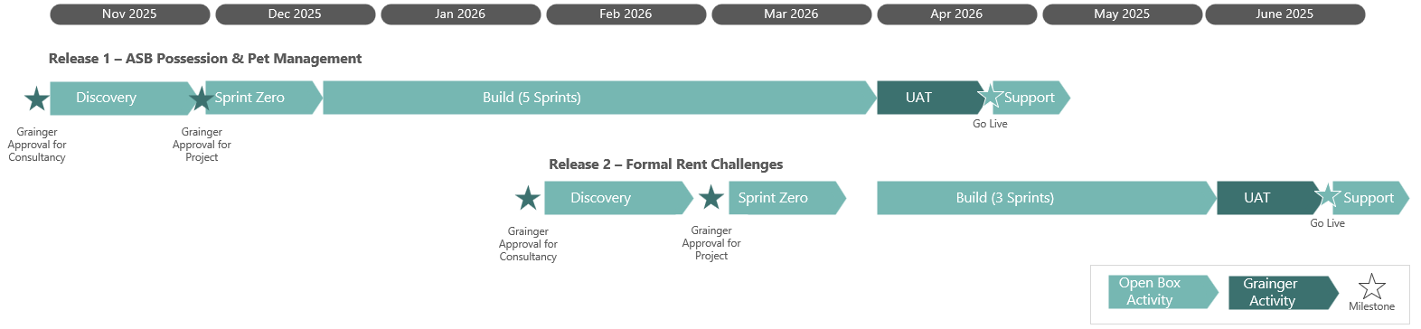
Figure 8: Estimated Project Timeline & Phasing – Upper Bound Timeline

Table 3: Estimated Project Cost – Release 1 Pets & ASB Possession
Phase | Duration | Lower Bound | Upper Bound
Discovery | 4 weeks | £ 16 300 | £ 32 600
Sprint 0 | 3 weeks | £ 8 150 | £ 9 780
Build: 3 – 5 sprints | 9 – 15 weeks | £ 128 995 | £ 214 992
UAT | 3 weeks; completed in parallel with release 2 | £ 6 143 | £ 6 143
Production Deployment & Post Go-Live Support | 2 weeks; completed in parallel with release 2 | £ 4 095 | £ 4 095
User Guide | Done in parallel with sprints | £ 2 068 | £ 3 260
Total | 21 - 27 weeks | £ 166 291 | £ 270 869

Table 4: Estimated Project Cost – Release 2 Formal Rent Challenges
Phase | Duration | Lower Bound | Upper Bound
Discovery | 4 weeks; completed in parallel with release 1 | £ 8 150 | £ 16 300
Sprint 0 | 3 weeks; completed in parallel with release 1 | £ 8 150 | £ 9 780
Build: 2 - 3 Sprints | 6 – 9 weeks | £ 85 997 | £ 128 995
UAT | 3 weeks | £ 6 143 | £ 6 143
Production Deployment & Post Go-Live Support | 2 weeks | £ 4 095 | £ 4 095
User Guide | Done in parallel with sprints | £ 1 304 | £ 1 956
Total | 18 - 21 weeks | £ 113 838 | £ 167 269

Table 5: Estimated Total Project Cost (2 Releases)
Project Total | 27 - 36 weeks | £ 280 129 | £ 438 138

All amounts are quoted in GBP (£) and exclude VAT, if applicable.
Project costs will be billed monthly, in arrears.
This quotation is valid for 30 days.
Cost is subject to change if project duration increases outside of Open Box control.
- Dependencies
Costs and timelines are contingent on:
- Grainger making a project sponsor available to facilitate decision-making.
- The appropriate Grainger stakeholders being available throughout the project, including participation in the activities (and within the timelines) detailed in the Delivery approach.
- Grainger completing UAT within the time period specified above.
- Grainger delivering any required information or content (such as document and email templates) in a timely manner.
- Grainger completing GREP integration work and styling the necessary FormAssembly pages within the agreed timeframe.
- Finalised Renters’ Rights Bill legislation prior to the start of the Formal Rent Challenge functionality.
- If a phased approach is adopted: There being no delay between the completion of the first release’s build phase and the start of the second release’s build phase.
- Next Steps
The proposed next steps are:
- Grainger to approve the proposal and confirm whether to proceed with a phased approach (addressing Formal Rent Challenges in a separate release) or whether to proceed as a single release.
- Open Box to provide a Statement of Work for the discovery phase.
- Grainger to approve the Statement of Work.
- Open Box to complete discovery analysis, deliver the artefacts detailed above (see Discovery Phase Consulting) including an updated cost estimate.
- Acceptance
The parties hereto, each acting under due and proper authority, have executed this Agreement as of the day, month and year first written below.

For and on behalf of Open Box Software For and on behalf of Grainger plc

Signature: _____________________ Signature: _____________________

Name: _____________________ Name: _____________________

Position: _____________________ Position: _____________________

Date: _____________________ Date: _____________________
- Appendix A – Grainger Mock-Ups
Grainger have provided some indicative screen mock-ups. These mock-ups are not final and are purely to facilitate requirements and design discussions.
Revised screen mock-up will be reviewed and agreed during the design phase of the project.
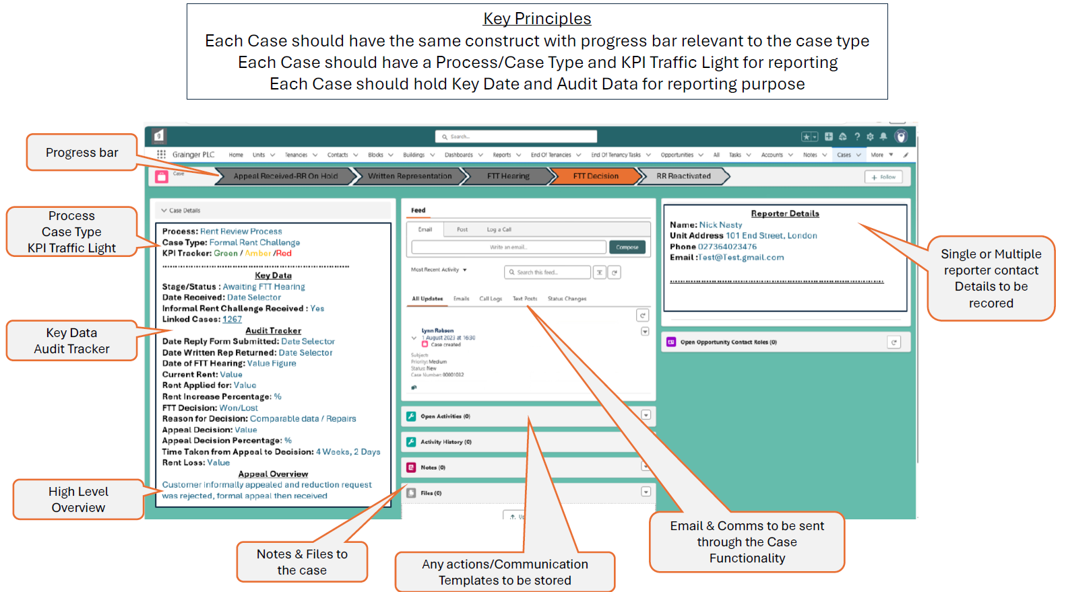
- Formal Rent Challenge case:
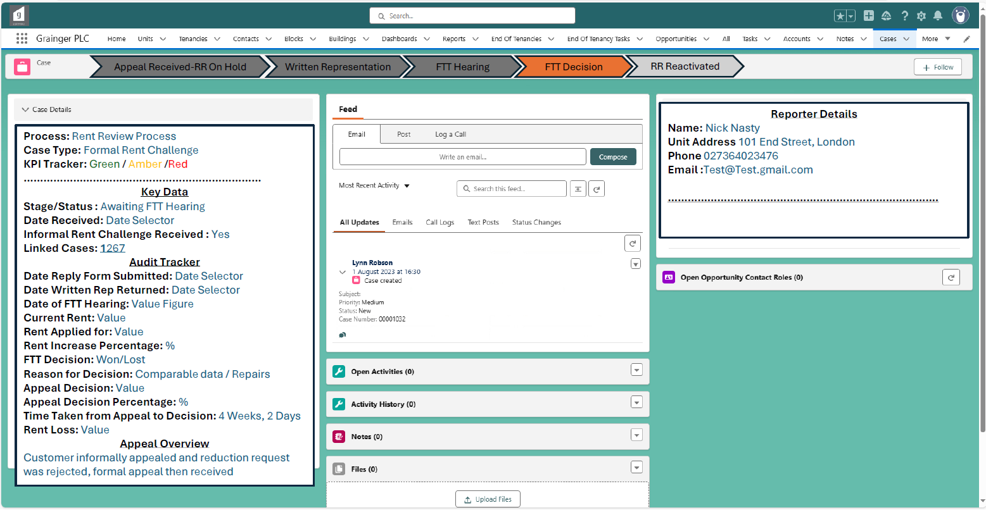
- ASB Possession Case:
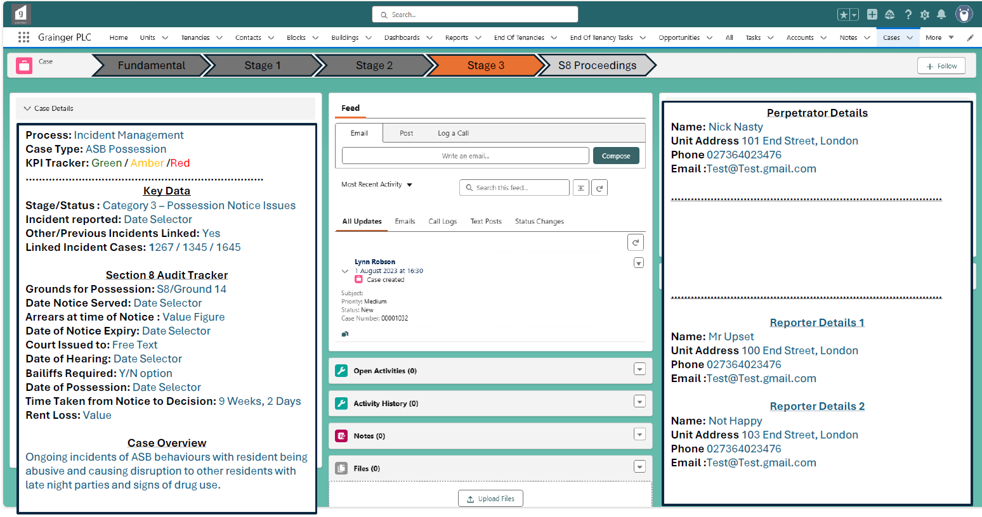

- Pet Management Case:
